Project 1: Martingale Report

Shrikanth Mahale

**Abstract—Simple Gambling Simulator Creation.**

**Experiment 1: Explore the strategy and make some charts:**

1. **Question 1: In Experiment 1, based off the experiment results calculate the estimated probability of winning $80 within 1000 sequential bets. Explain your reasoning for the answer using the experiment thoroughly (not based on plots).**

**Answer**: In Experiment 1, the probability of winning $80 within 1000 sequential bets is 100%. The reason for this is, every time we lose the bet, the bet amount is doubled for the next bet which makes us recover the lost money from the next win whenever it occurs. The net profit for winning the bet is $1, so we need to win maximum 80 times to win $80 during the 1000 sequential bets. The probability of winning one bet is 18/ (36+2). In order to not win $80, we have to lose at least 921 times.

Therefore, the probability of losing 921 times will be

(1000! / ((1000−921) *!921!)) *(1 – 18/38) * 921 * (18/38) ^79 = 2.0202 × 10^−164 which approximately equal to zero.

Figure 1 below shows that after 10 simulations, the winnings of each of the simulations stabilizes at approximately $80. Figure 2 below also shows that after 1000 simulations, the winnings of each of the simulations stabilizes at approximately $80.

1. **Question 2: In Experiment 1, what is the estimated expected value of winnings after 1000 sequential bets? Thoroughly explain your reasoning for the answer. See the following Wikipedia entry to learn about expected value: https://en.wikipedia.org/wiki/Expected_value**

**Answer**: In Experiment 1, the estimated expected value of winnings after 1000 sequential bets is $80. Looking at Figure 2, it seems that mean of each of 1000 simulations ends up being at $80 after approximately 200 bets. Therefore, based on my analysis in question 1 above and the analysis looking at Figure 2, it is safe to say that the expected value withing 1000 sequential bets is $80.

1. **Question 3: In Experiment 1, do the (mean + standard deviation) line and (mean – standard deviation) line reach a maximum value then stabilize? Do the lines converge as the number of sequential bets increases? Explain why it does or does not thoroughly.**

**Answer**: In Experiment 1, If we look at Figure 3, the standard deviation is all over the place. It is neither reaching the peak value and then converging nor it is stabilizing. But however, as the mean of the winnings stabilizes at 80, the standard deviation goes towards zero and stabilizes. This indicates that as the winnings end up reaching $80, there is no variance between the winnings. Therefore, this leads to standard deviation being 0 as the mean of winnings in Experiment 1 stabilizes.

**Experiment 2: A more realistic gambling simulator:**

1. **Question 4: In Experiment 2, based off the experiment results calculate the estimated probability of winning $80 within 1000 sequential bets. Explain your reasoning for the answer using the experiment thoroughly. (not based on plots).**

**Answer**: In Experiment 2, while performing the experiment in the code, it was observed that the average mean of the winnings is approximately -40 when the winnings are either at $80 or -$256 for the 1000 sequential bets. Suppose the probability of winning 80 dollars is P, the expected value should be approximately equal to the mean value of 1000 sequential bets. Therefore, the Probability can be calculated using the equation below:

(1-P) * (-256) +(P) * 80 = -40

Solving the above equation, we get P = 0. 64 = 64%. So, the probability of winning $80 is 64%.

1. **Question 5: In Experiment 2, what is the estimated expected value of our winnings after 1000 sequential bets? Thoroughly explain your reasoning for the answer (not based on plots).**

**Answer:** As explained in the answer to question 4, while performing the experiment in the code, it was observed that the average mean of the winnings is approximately -40 when the winnings are either at $80 or -$256 for the 1000 sequential bets. Therefore, the estimated expected value is -$40.

1. **Question 6: In Experiment 2, do the (mean + standard deviation) line and (mean – standard deviation) line reach a maximum value then stabilize? Do the lines 3 converge as the number of sequential bets increases? Explain why it does or does not thoroughly.**

**Answer:** Yes, the mean + standard deviation increases gradually and then stabilizes as the number of sequential bets increases. This is because the winnings also stabilize at either $80 or -$256 as the number of sequential bets increases. As most of the winnings fall into one of these two categories, the standard deviation also stabilizes because there is no variance between these two categories.

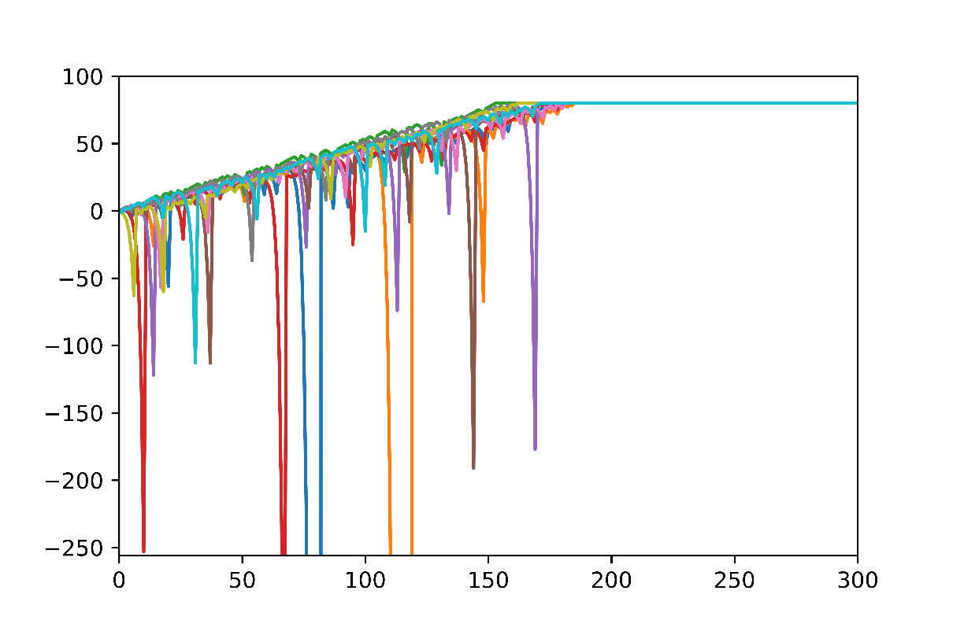

***Figure 1-***Winnings with 10 simulated runs

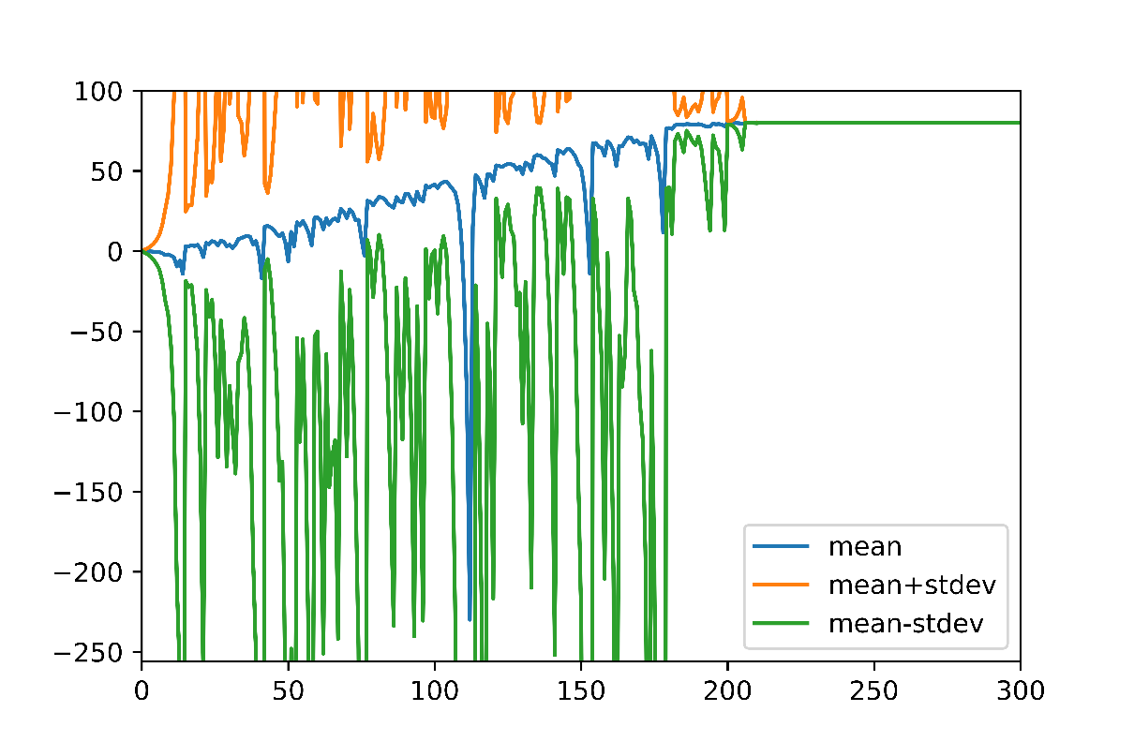

***Figure 2-***Mean Winnings with Unlimited cash (+/-stdev)

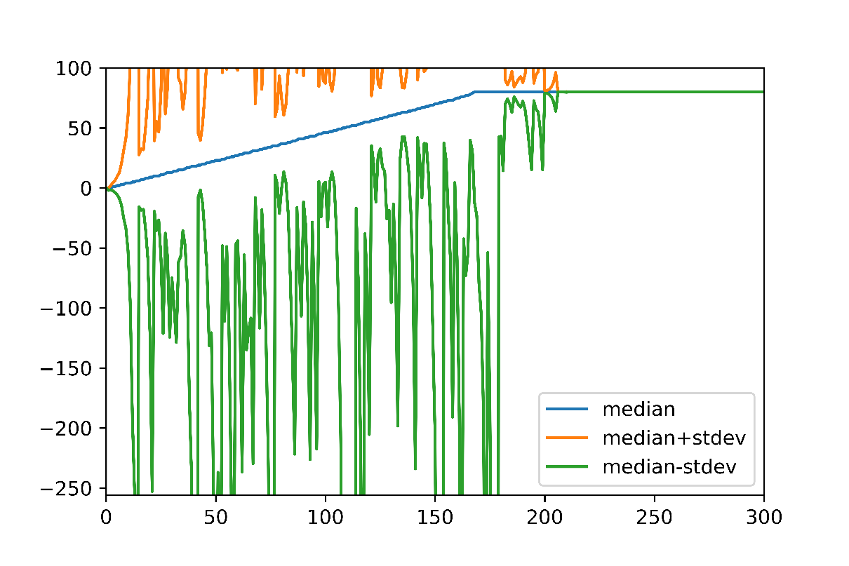

***Figure 3-***Median Winnings with Unlimited cash (+/- stdev)

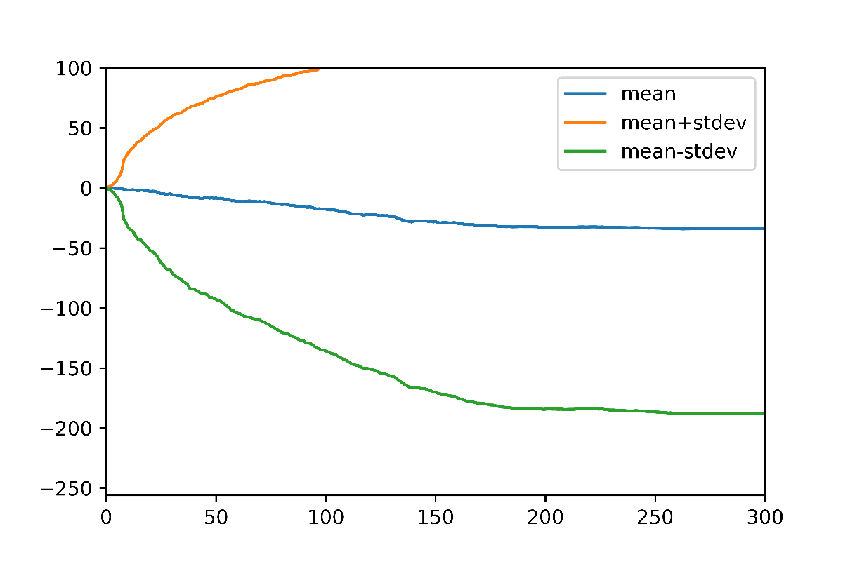

***Figure 4-***Mean Winnings with limited cash (+/- stdev)

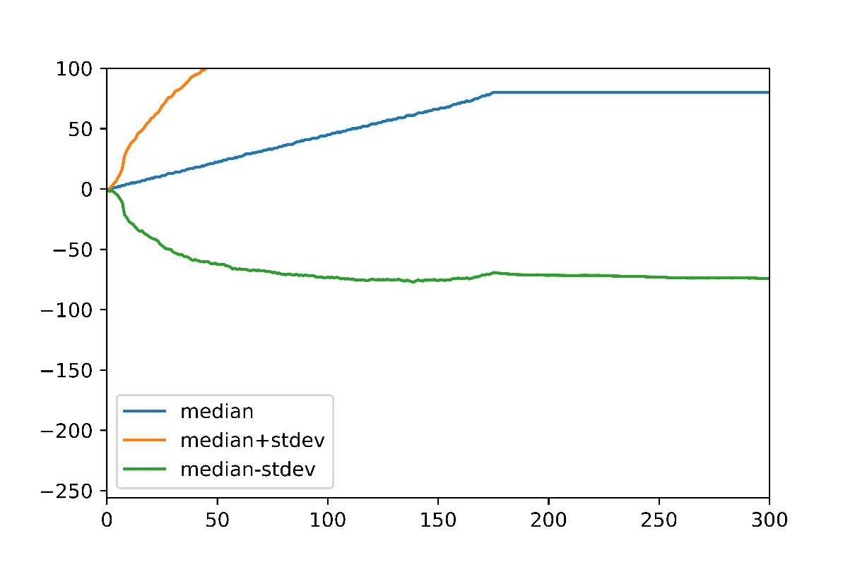

***Figure 5-***Median winnings with limited cash (+/- stdev)